**GROUP MEMBER**

**TRM 4A (REGULER NIGHT) :**

1. **4312211020 – DWI KURNIA SAPUTRA**
2. **4312211006 – ABDUL AJIS**
3. **4312211023 – MUHAMMAD REZA AL FARIZI**
4. **4312211025 – DWIKI KHARISMA**
5. **4312211029 – JESI AFRIANA**

# PROJECT IDENTITY

Project Title : Mobile Scale Application

Project Owner : TRM

Project Manager : Agung Riyadi. S.Si., M.Kom

Project Co-Manager : -

Client : Agung Riyadi. S.Si., M.Kom

|  |  |
| --- | --- |
| ✓ | Final Report |
| ✓ | Product: *Mobile Application*/Hardware/video* |
| ✓ | Demo video /trailer* |
| ✓ | Scientific Poster |
| ✓ | Intellectual Property Rights Document |
| ✓ | Handover Document |
|  | Contest Proposal (optional) |

Outputs :

Approved by,

Batam, 24 Juni 2024

**Agung Riyadi. S.Si., M.Kom**

**NIK. 119221**

# LIST OF CONTENT

PROJECT IDENTITY iii

LIST OF CONTENT iv

LIST OF FIGURES vi

LIST OF TABLES vii

1. PROJECT-BASED LEARNING PRODUCT viii

1.1 Product Description viii

1.2 Product Design viii

1. 2. 1 General system description. viii

1. 2. 2 Functional system requirements. ix

1. 2. 3 Use Case ix

1. 2. 4 ER Diagram ix

1. 2. 5 Product interface/architecture design. ix

1. 2. 6 Programming Language ix

2. PRODUCT IMPLEMENTATION x

2.1 Product Implementation x

3. CONCLUSION 1

3.1 Obstacle 1

3.2 Learning Process 1

APPENDIX I – LOGBOOK 3

APPENDIX II – TEAM SCHEDULE 4

APPENDIX III – PROJECT BOARD 5

APPENDIX IV – PRESENTATION SLIDES 8

APPENDIX … – …. 17

# LIST OF FIGURES

Figure 1. 1 UseCase viii

Figure 1. 2 Product interface viii

Figure 1. 3 Implementation userinterface ix

Figure 1. 4 Product testing result x

Figure 1. 5 LogBook 3

Figure 1. 6 Project Board 7

Figure 1. 7 Slides Presentation 16

# 

# LIST OF TABLES

Table 1. 1 Functional System Requirements vii

# PROJECT-BASED LEARNING PRODUCT

## Product Description

The mobile scale app is an innovative tool designed to simplify the measurement of kitchen ingredients, particularly spices, for both professional chefs and home cooks. The app connects with a digital scale via Wifi, providing real-time weight measurements directly on the user's mobile device. This product aims to enhance accuracy in cooking, reduce preparation time, and streamline the cooking process.

## Product Design

Product design for a mobile scale application project should have the following design:

### 1. 2. 1 General system description.

The Mobile Scale App is an advanced system designed to provide an accurate measurement solution by using an ESP8266 microcontroller, a 10kg load cell, and an HX711 sensor. The system aims to provide measurement data wirelessly and in real-time to the user through a dedicated mobile app. The load cell, which is capable of measuring weight up to 10kg, serves as the main sensor for detecting weight, while the HX711 sensor serves as an analog-to-digital converter (ADC) that processes the signal from the load cell. The ESP8266 microcontroller handles data transmission, utilizing its built-in Wi-Fi capabilities to communicate seamlessly with the mobile app.

The core functionality of the system revolves around the precise measurement capabilities of the load cell and the HX711 sensor. When an object is placed on the load cell, it generates an electrical signal proportional to the weight of the object. The HX711 sensor amplifies this signal and converts it into a digital form that can be processed by the ESP8266 microcontroller. The ESP8266 then sends this data over a Wi-Fi network to a mobile app. This app, which can be developed using frameworks such as Flutter or React Native, displays real-time weight data to the user. The app also provides additional functions such as result, tare, and reset.

The Mobile Scale App ensures reliability and ease of use. The system is designed to be easy to use, with easy setup procedures and no technical expertise required. Users can simply connect the scale to their mobile device and start receiving weight measurements immediately. Wireless communication facilitated by ESP8266 allows for greater flexibility and mobility. By integrating the right measurement components with modern wireless technology, the Mobile Scale App offers a robust and efficient solution to contemporary weighing needs.

### 1. 2. 2 Functional system requirements.

Table 1. 1 Functional System Requirements

|  |  |  |
| --- | --- | --- |
| No | Functional System Requirement Description | Achieved (✓) /  Not Achieved (**x**) |
| 1 | User can open and use the mobile scale application at ease. | ✓ |
| 2 | User can connect the mobile application to the scale device via Wi-fi. | ✓ |
| 3 | The application must be able to receive weight data from the scale device via Wi-fi. | ✓ |
| 4 | Data must be displayed accurately and in real-time on the application screen. | ✓ |
| 5 | The application can be used periodicaly. | ✓ |

### 1. 2. 3 Use Case

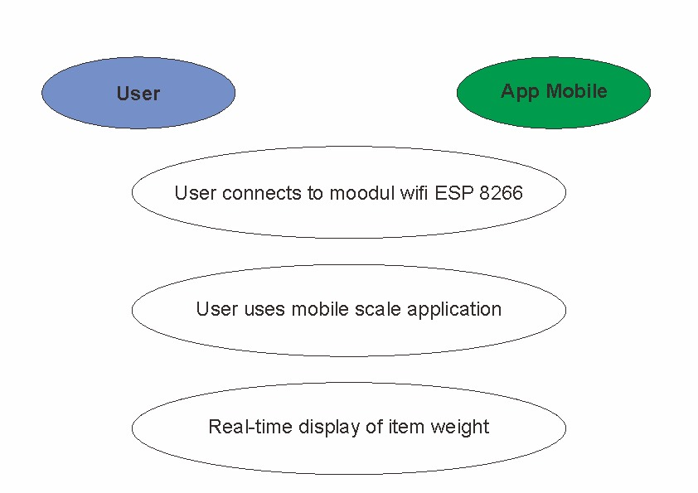

Figure 1. 1 UseCase

### 1. 2. 4 ER Diagram

*not using a database.*

### 1. 2. 5 Product interface/architecture design.

Figure 1. 2 Product interface

### 1. 2. 6 Programming Language

a. IoT Device : Arduino IDE

Language : C++

C++ is a high-level programming language often used for system and application software development due to its high performance and flexibility in directly managing resources and optimizing application performance. The language supports object-oriented programming, allowing the use of classes, objects, and polymorphism to make code development and maintenance easier.

b. Mobile Application : Flutter

Language : Dart

Dart is a modern language developed by Google, known for its efficiency and good performance. Dart is widely used for web and mobile application development, especially with the Flutter framework that enables cross-platform mobile application development (iOS and Android) by using a single Dart code. Dart also supports an optional type system, which provides flexibility in handling data types, and has an active community developing the language and its ecosystem.

# PRODUCT IMPLEMENTATION

## Product Implementation

Product implementation for mobile application projects:

1. Implementation for user interface / product design.

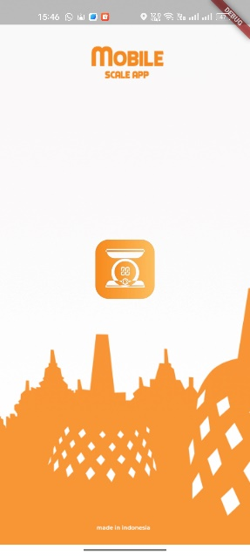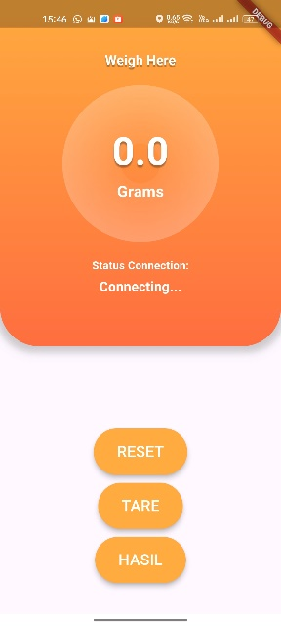

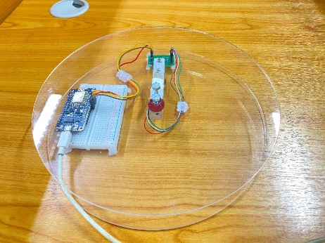

Figure 1. 3 Implementation userinterface

1. Product testing result.

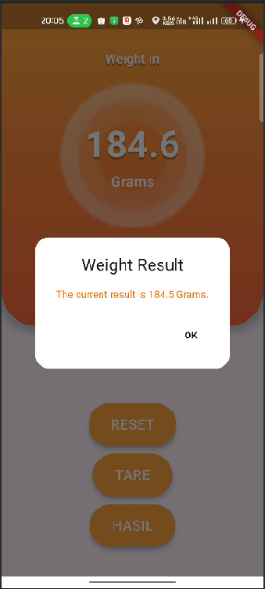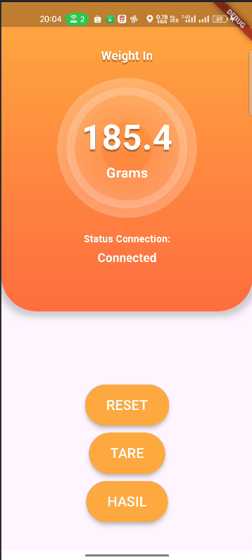

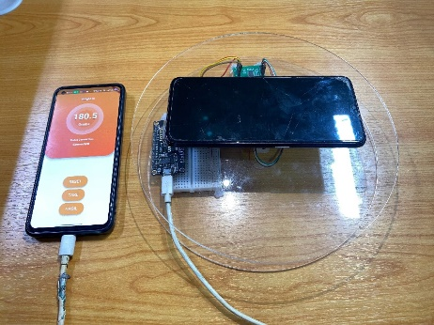

Figure 1. 4 Product testing result

# CONCLUSION

## 3.1 Obstacle

The challenges we face in carrying out this project include our limited understanding of Arduino programming and assembling IoT hardware. Additionally, building a mobile application using the Dart programming language is new to us, resulting in some mistakes made at the beginning of the project. Therefore, we need to learn more to successfully complete this project.

## Learning Process

#### 1. **Computer System Administration**

#### The principles of system management, network configuration, and server maintenance taught in this course were directly applied when setting up the backend systems and ensuring smooth communication between the app and the hardware. Concepts like user account management, network troubleshooting, and system security were essential for maintaining a robust development environment.

#### 2. **Object-Oriented Programming (OOP)**

#### The OOP course provided a strong foundation in designing software using classes and objects, which was crucial for structuring the mobile app’s code. We used principles of encapsulation, inheritance, and polymorphism to create a modular and maintainable codebase for the mobile scale application.

#### 3. **Mobile Device Programming**

#### This course provided the technical skills needed for developing mobile applications, including knowledge of development frameworks, debugging tools, and best practices for mobile UI design. Practical labs and assignments from this course were instrumental in building the technical foundation required to develop the mobile scale app.

#### 4. **IoT Multimedia System** Understanding the principles of IoT, including data communication protocols, sensor integration, and multimedia processing, was crucial for our project. We applied these principles to ensure seamless interaction between the scale and the app, as well as for processing and displaying the weight data effectively.

#### 5. **Statistics**

#### Statistical analysis skills were essential for interpreting data collected from the scale and ensuring its accuracy. We used statistical methods to analyze the performance of the scale, validate the measurement data, and optimize the app’s algorithms for better accuracy.

#### 6. **General English**

#### Proficiency in English was important for reading technical documentation, writing project reports, and communicating with team members. We used our English skills to document the project, create user manuals, and present our findings clearly and effectively.

#### 7. **Civic Education**

#### Civic Education instilled a sense of social responsibility and ethical considerations, which were important in ensuring that our project was designed with user privacy and data security in mind. We applied ethical principles to ensure that user data was handled responsibly and that the app was designed to be accessible and beneficial to the community.

# APPENDIX I – LOGBOOK

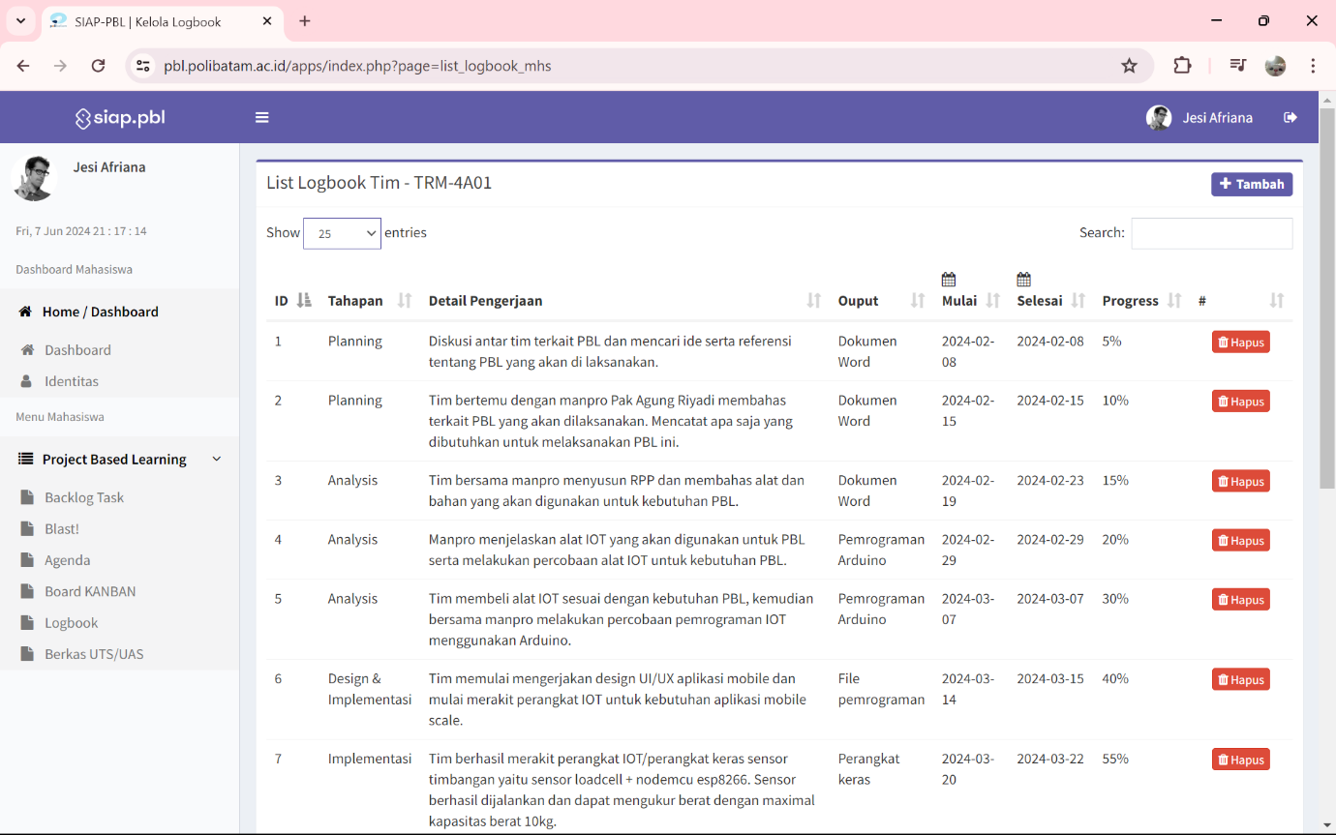

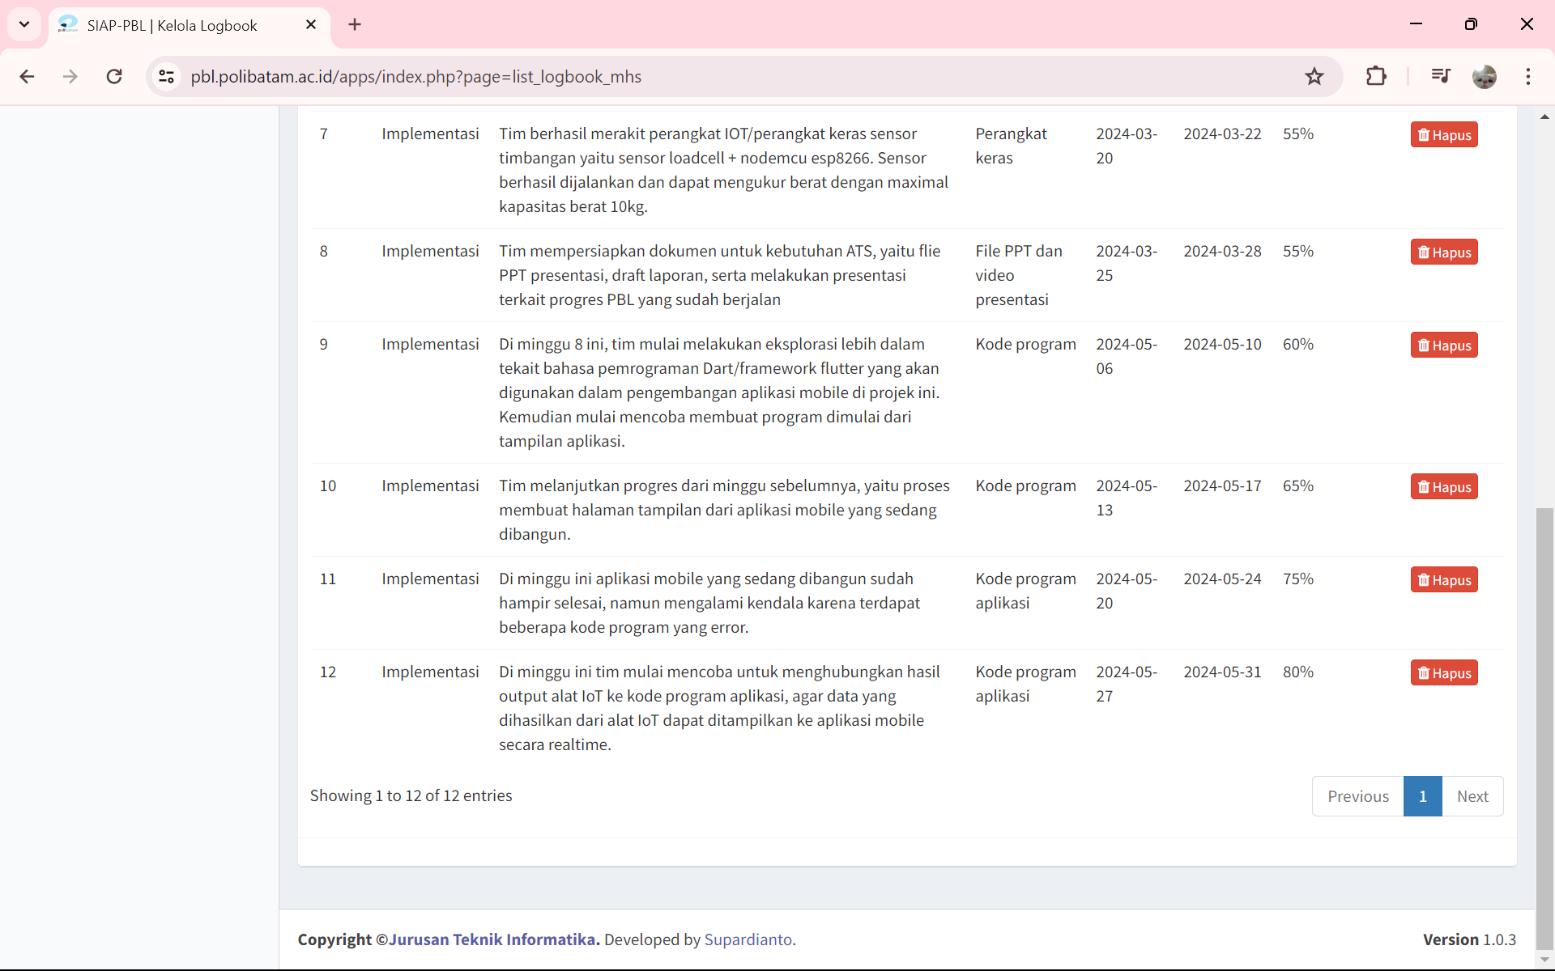

Figure 1. 5 LogBook

# APPENDIX II – TEAM SCHEDULE

The content for this section can be taken from the Project Management course.

# APPENDIX III – PROJECT BOARD

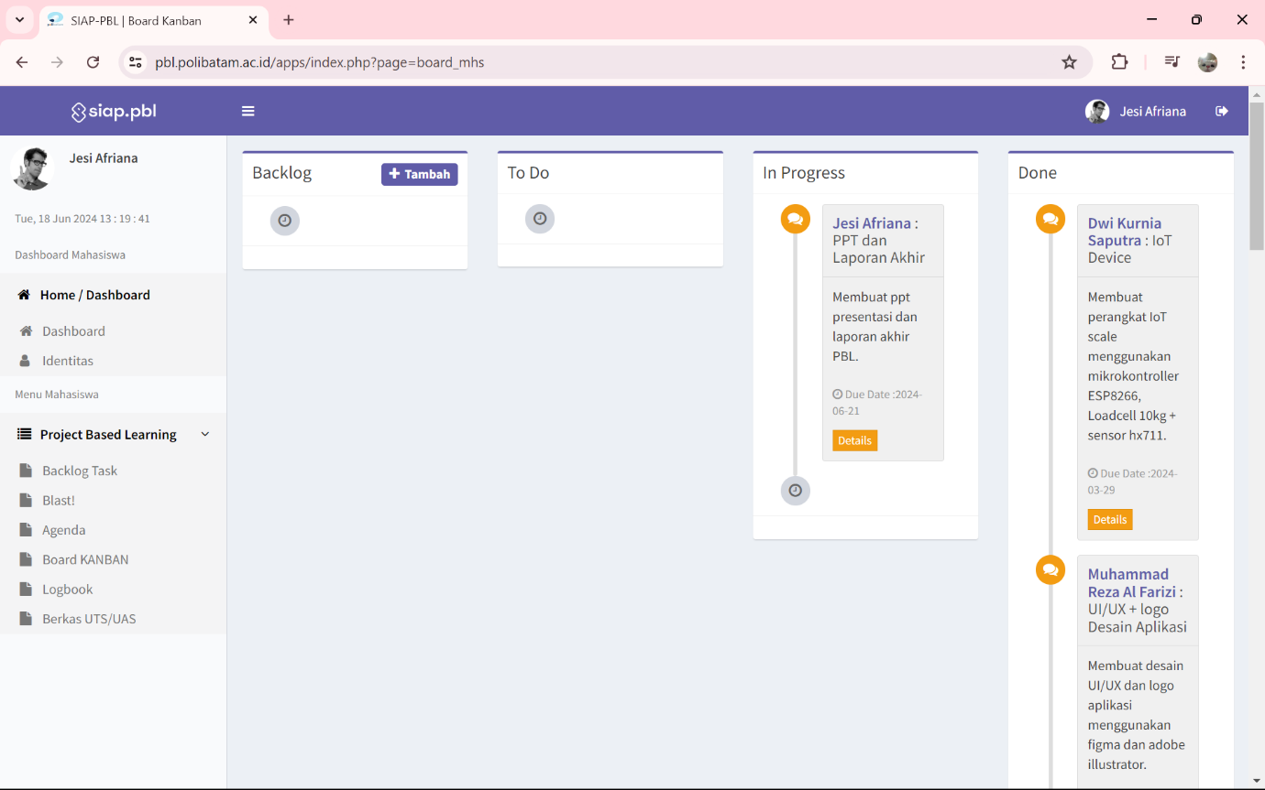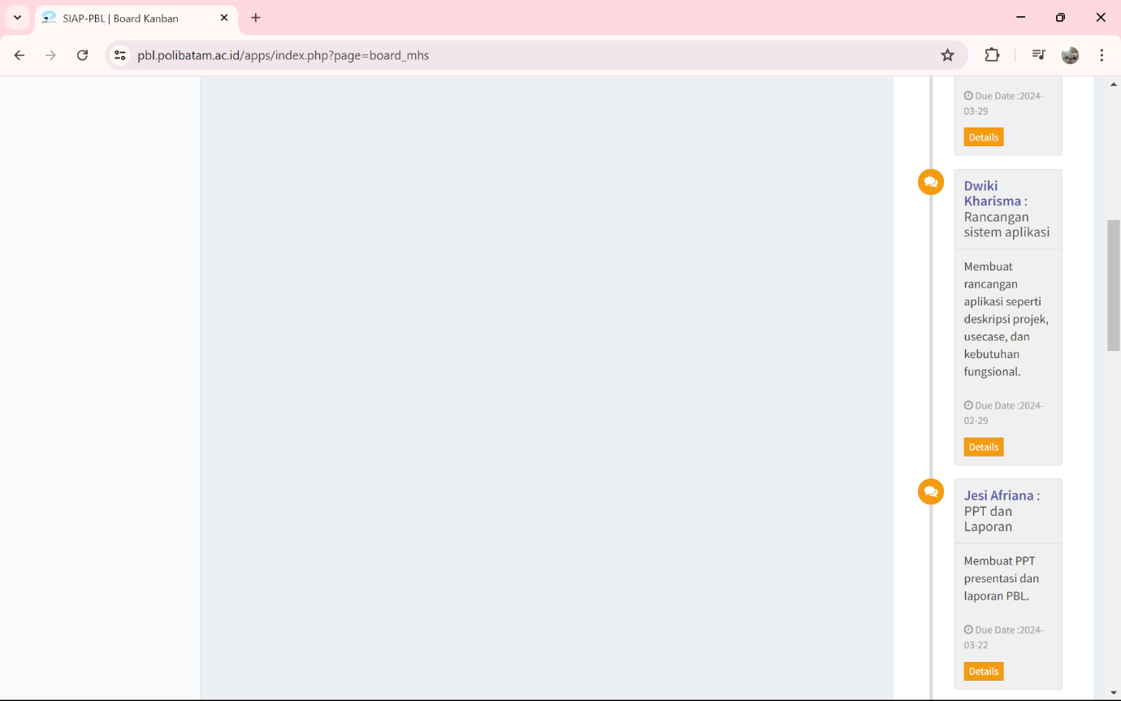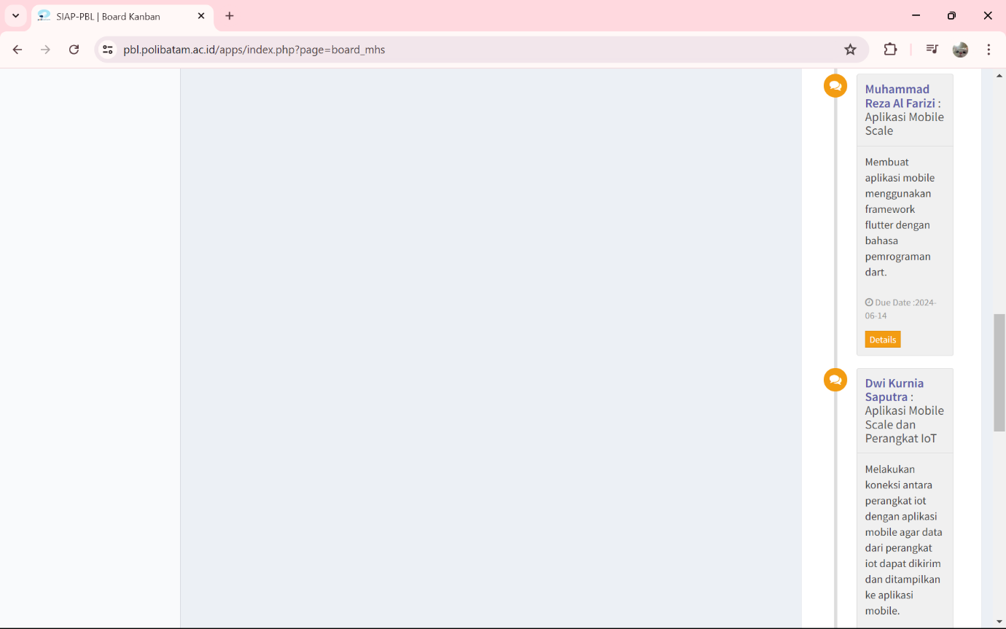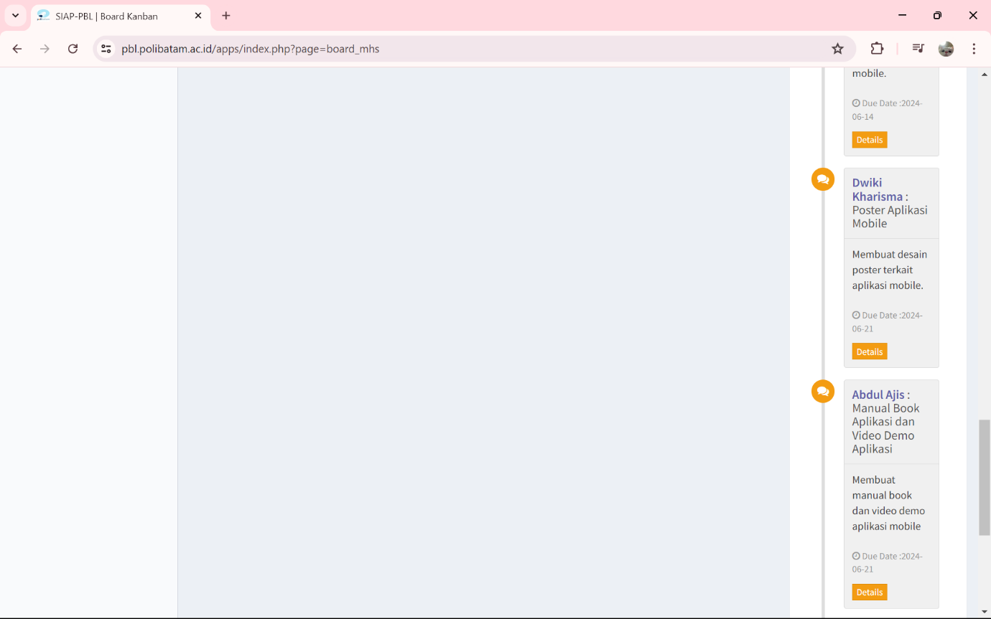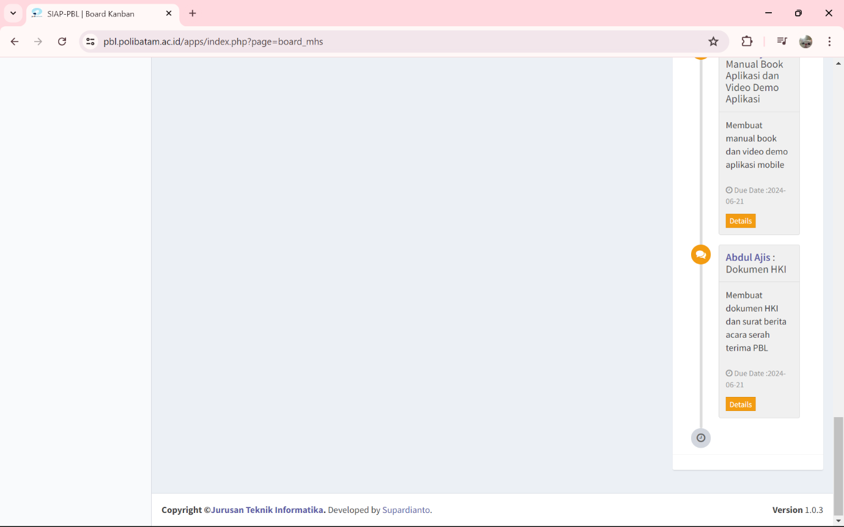

Figure 1. 6 Project Board

# APPENDIX IV – PRESENTATION SLIDES

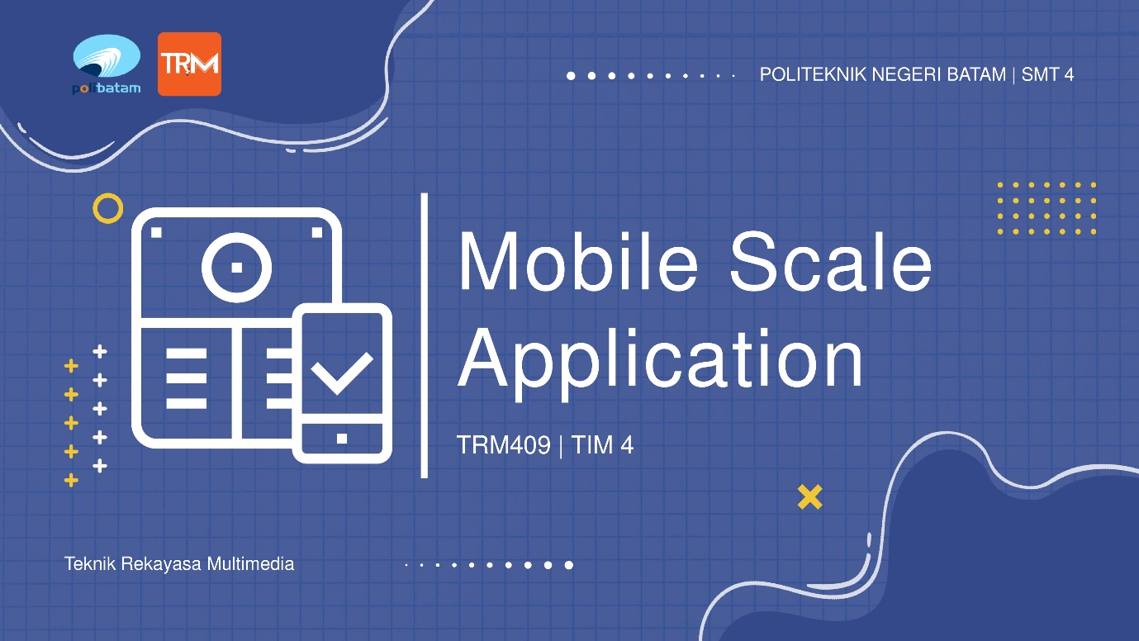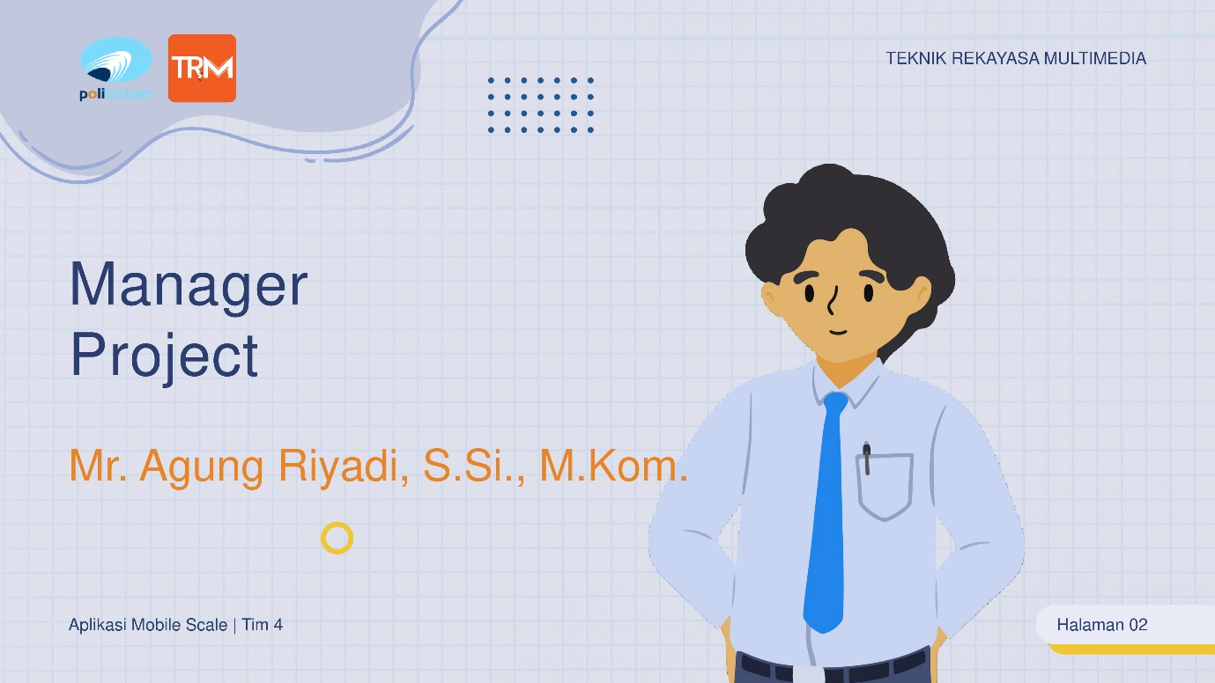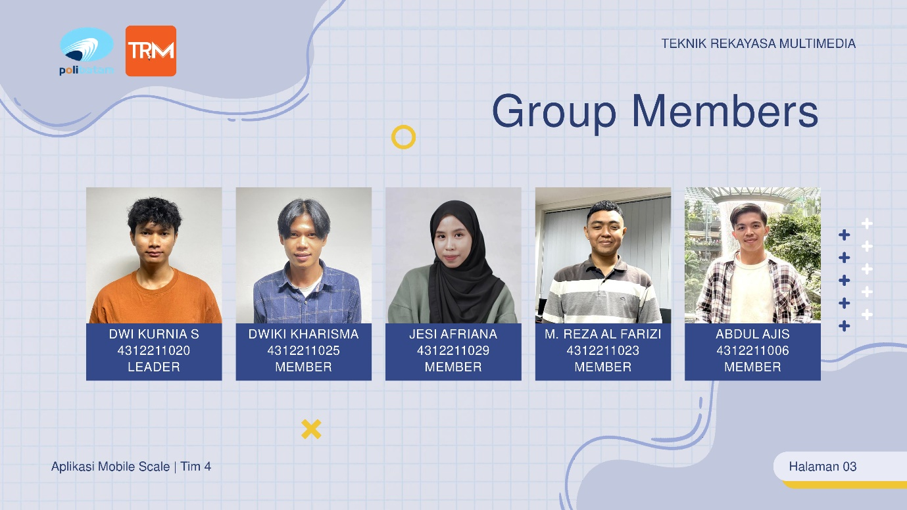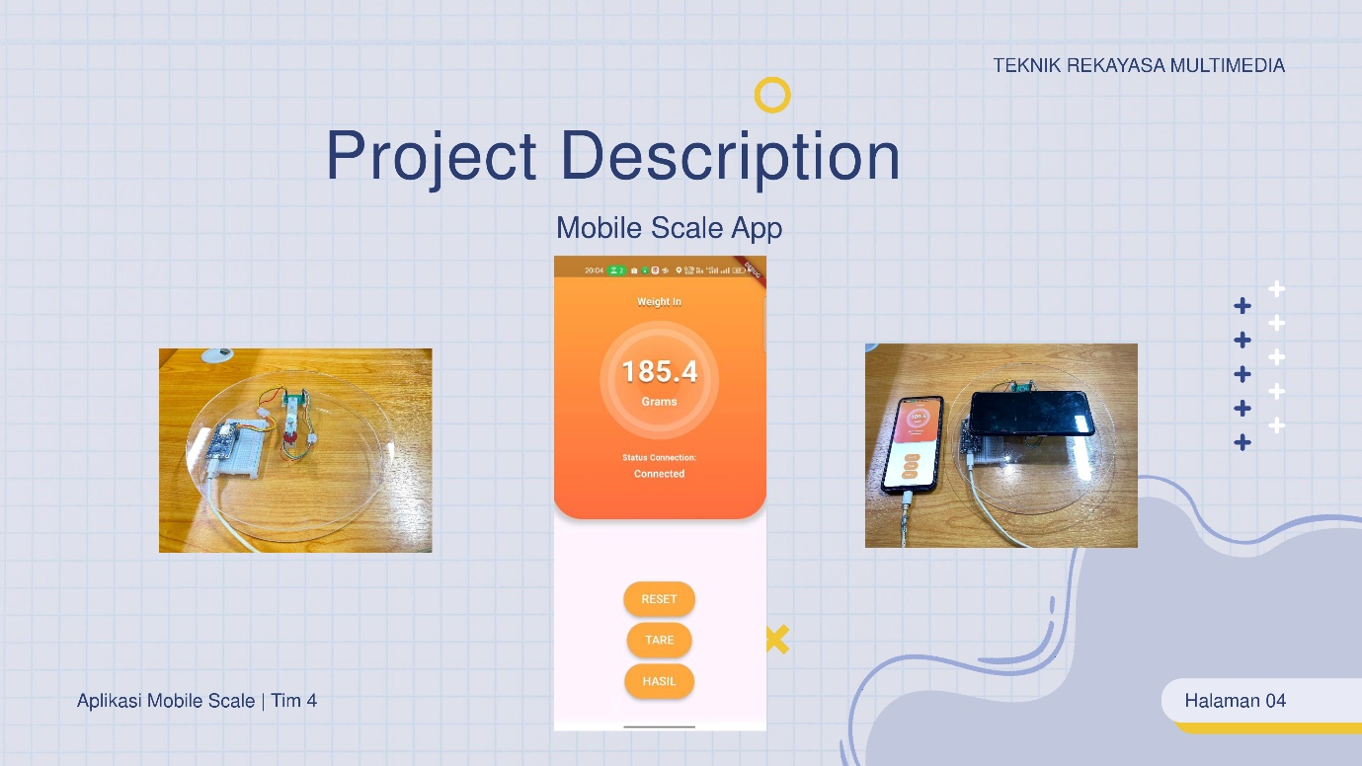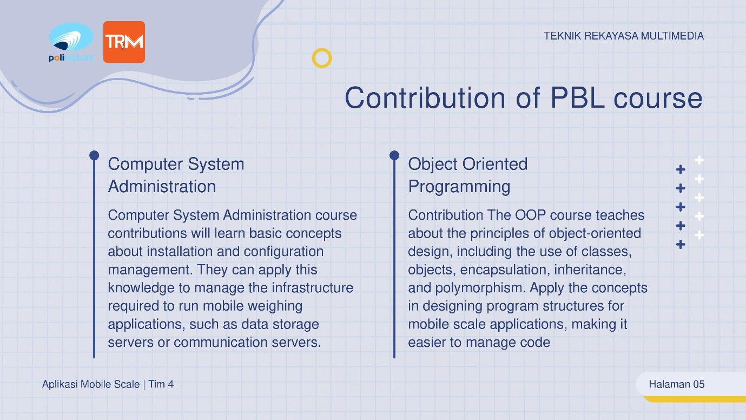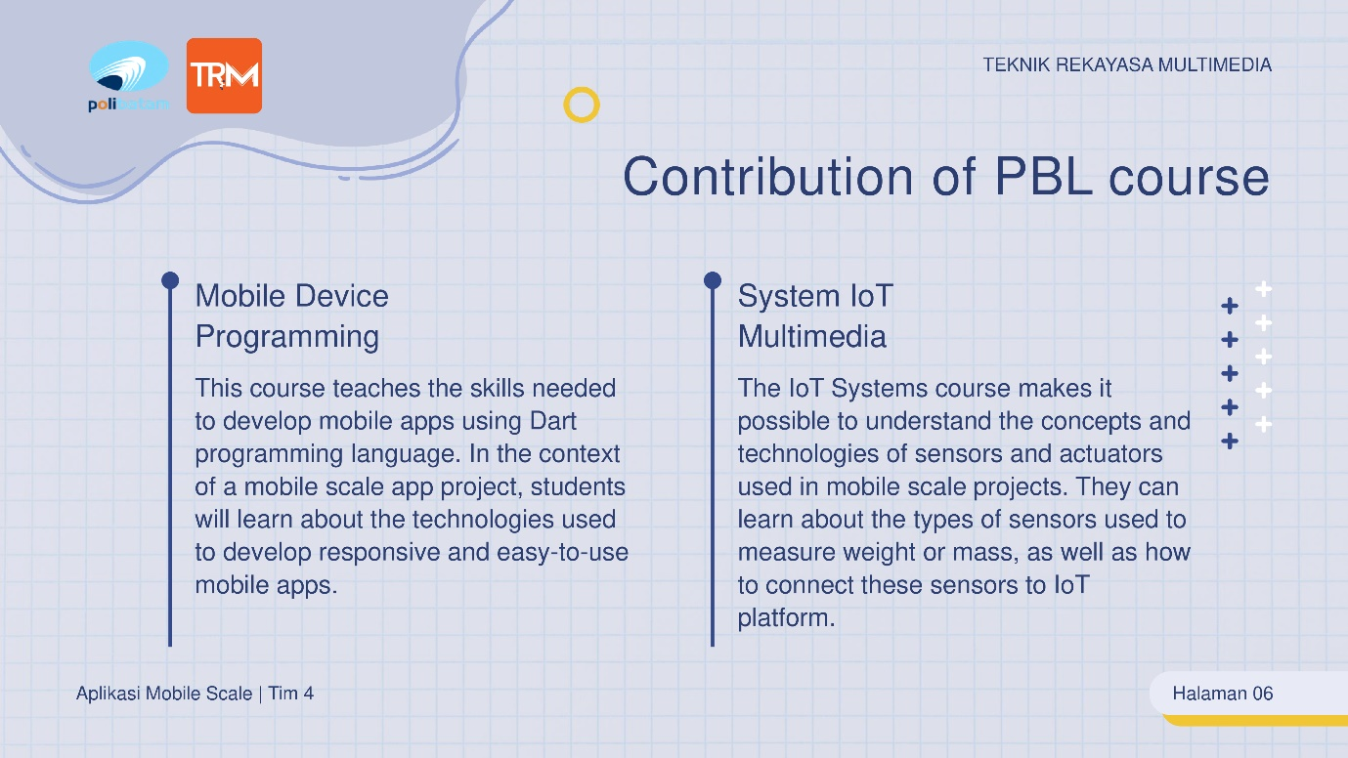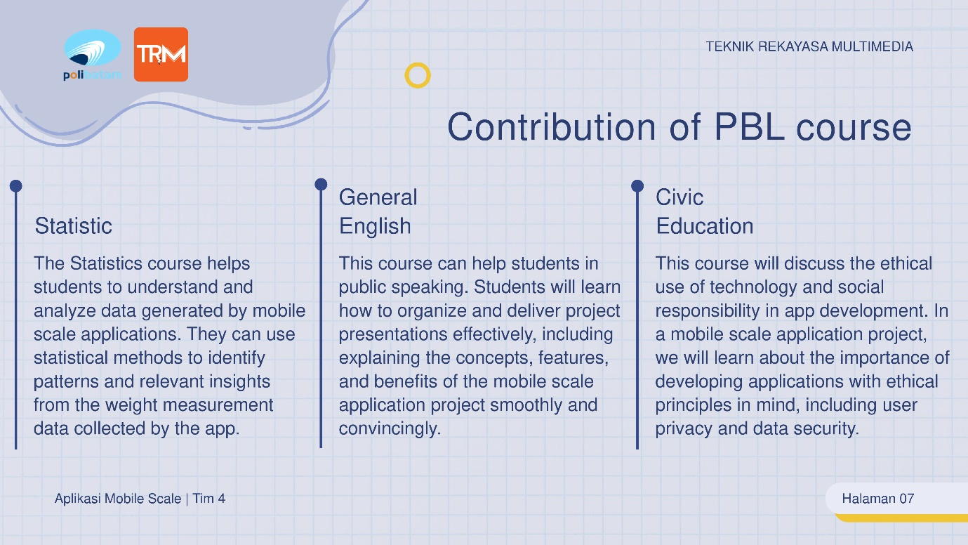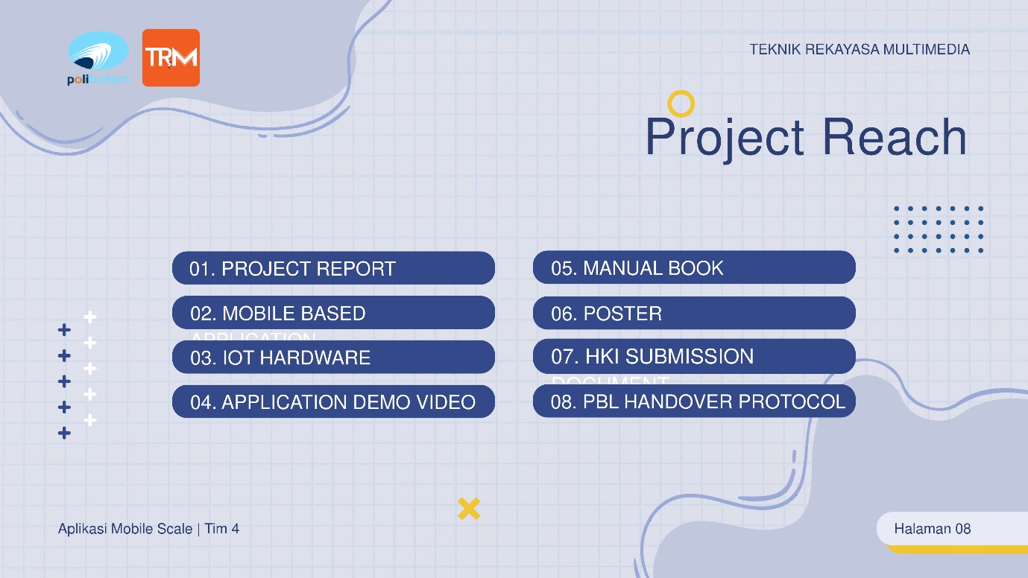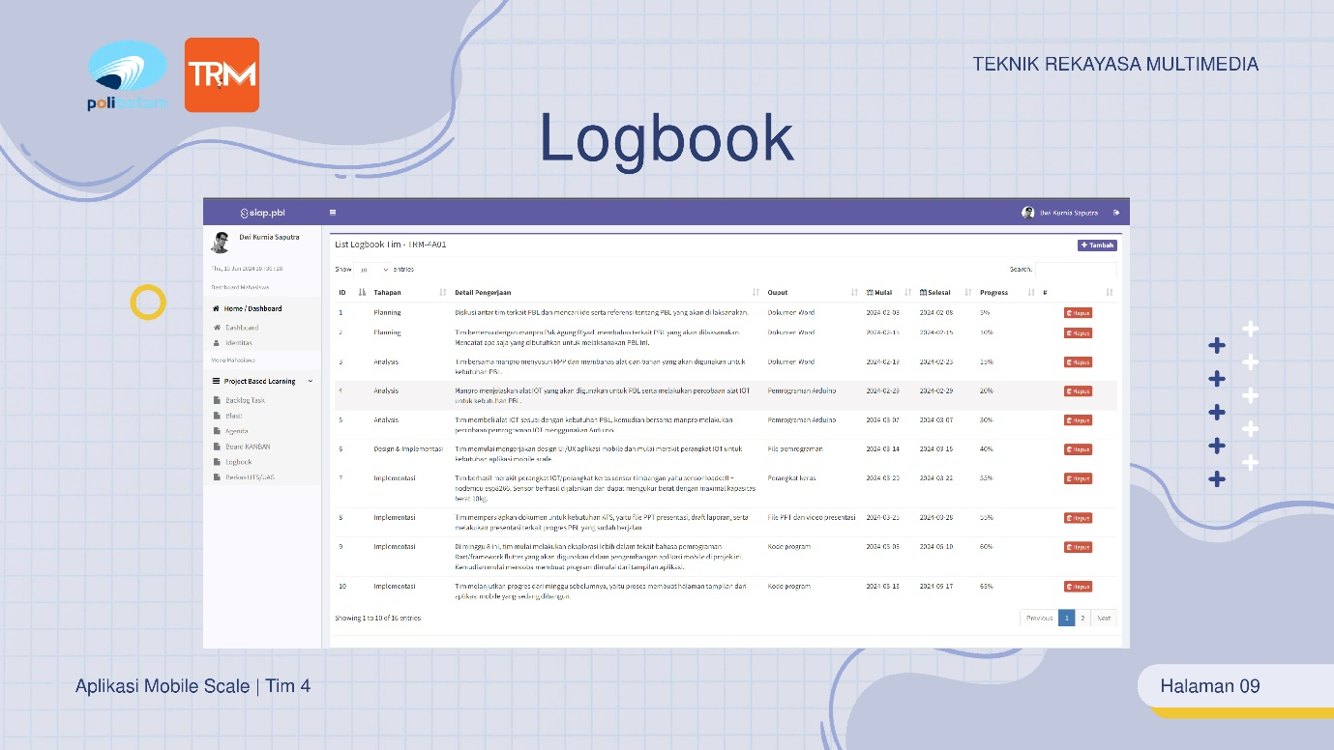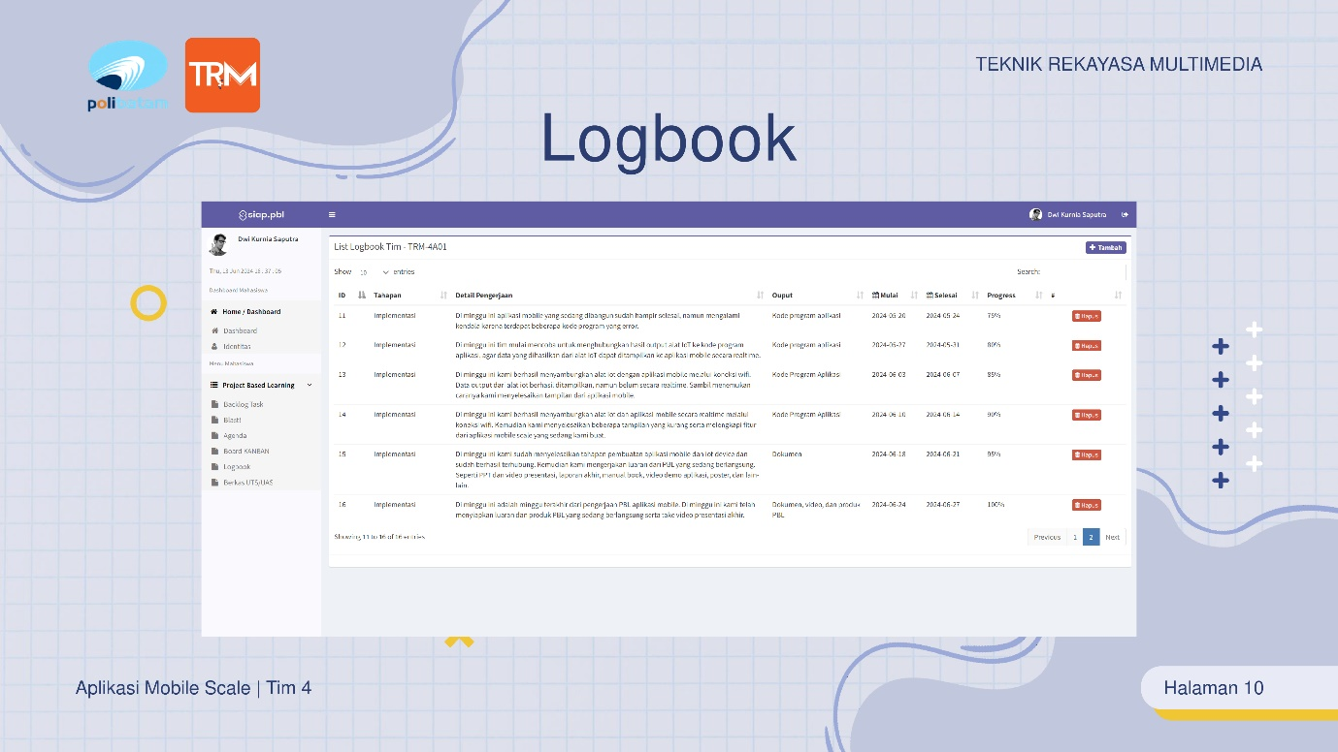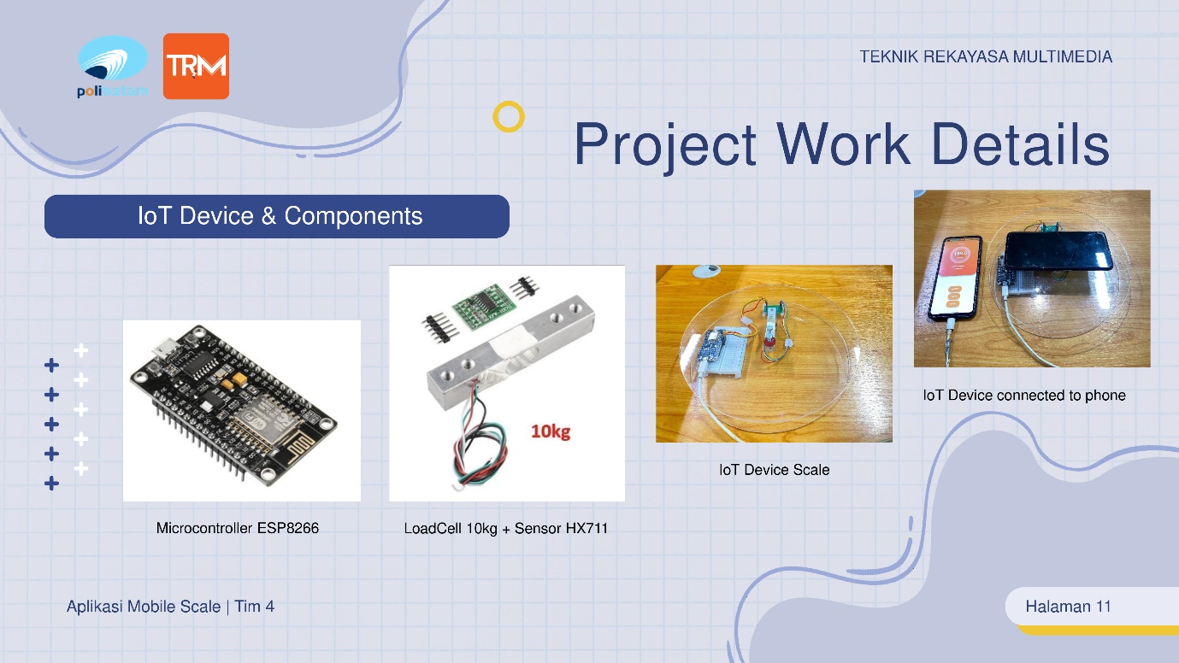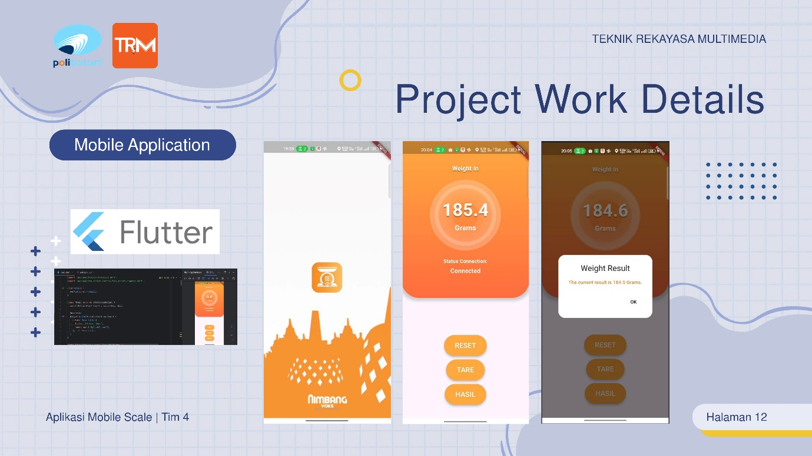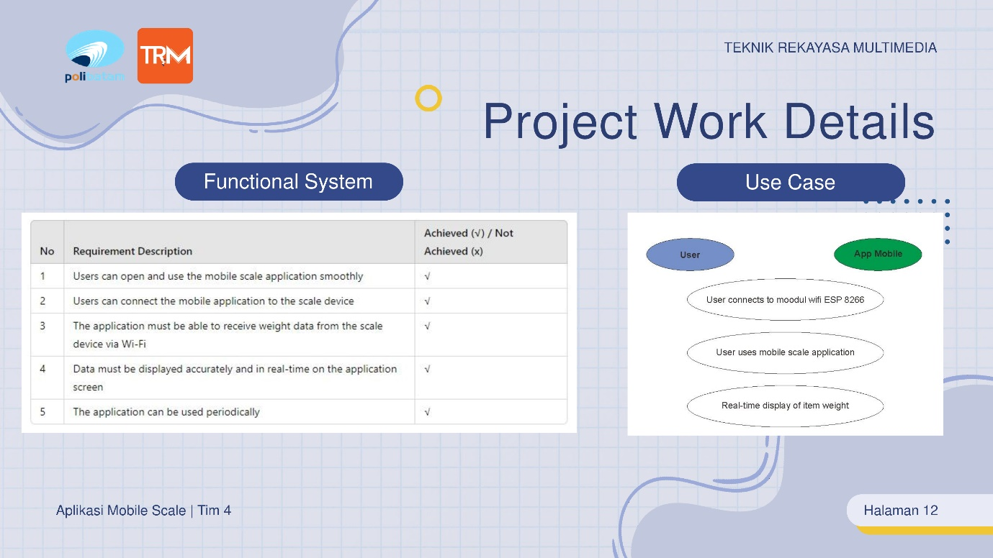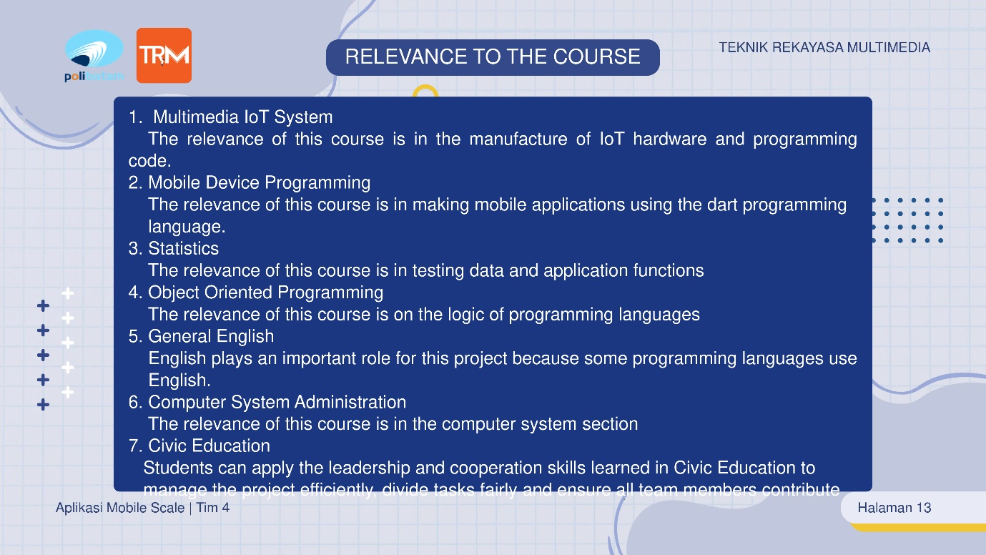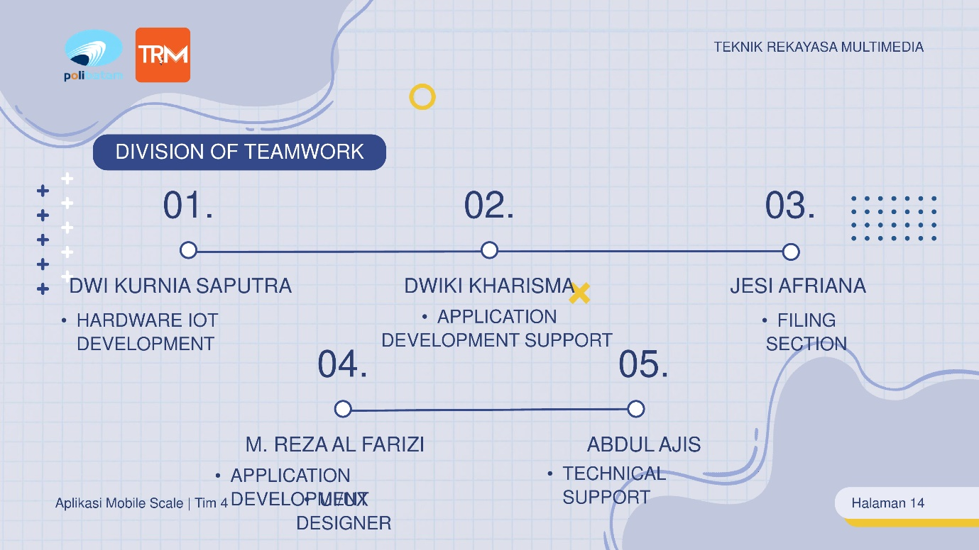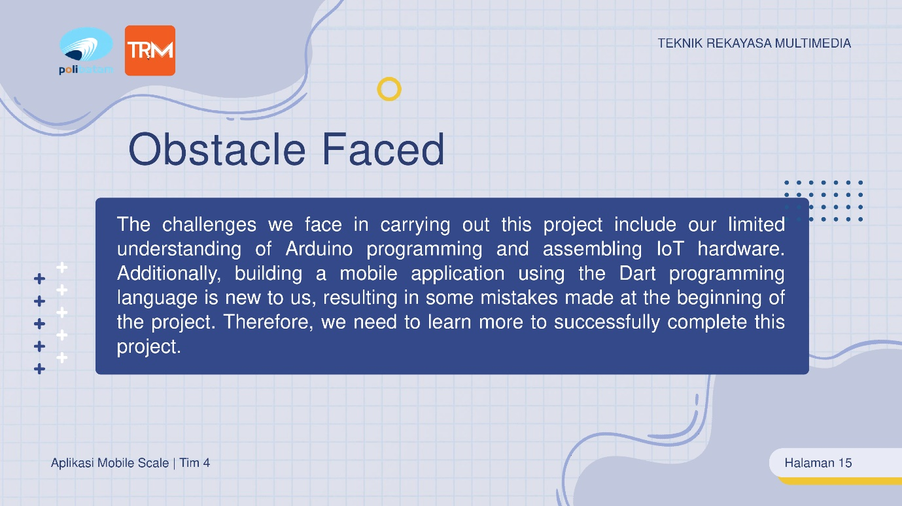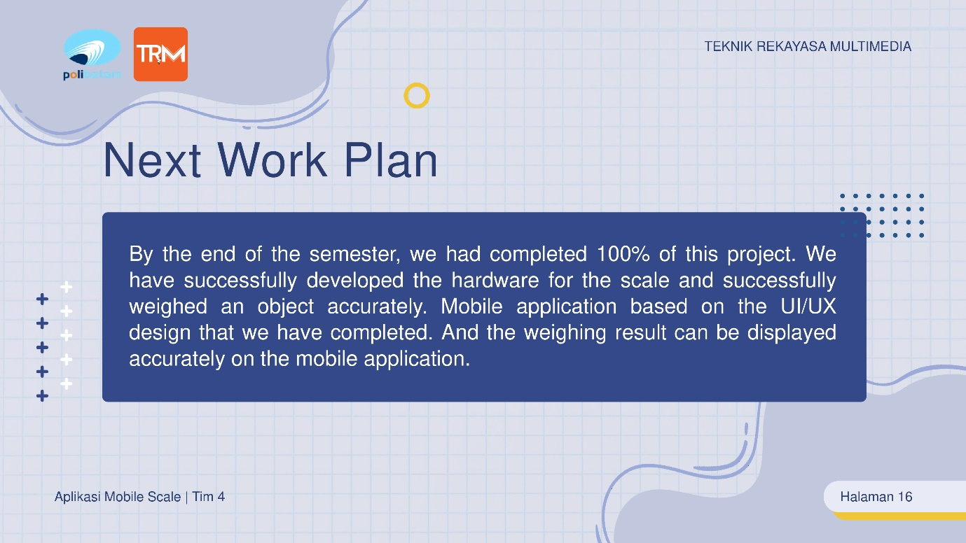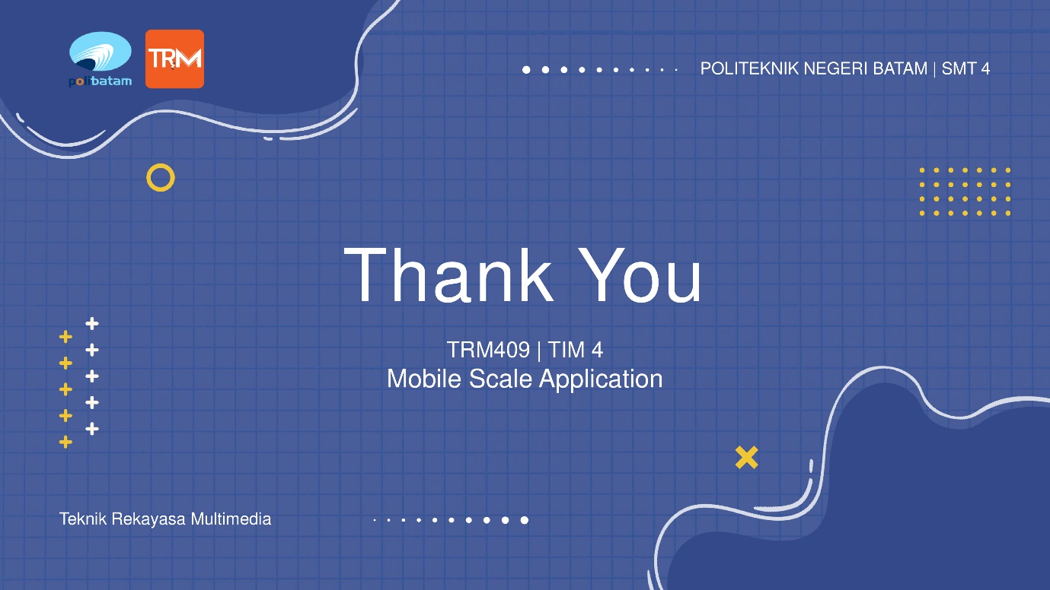

Figure 1. 7 Slides Presentation

# 

# APPENDIX … – ….

You can add appendices as needed such as:

1. Link of product

<https://drive.google.com/drive/folders/1A2r1XQqLjuSjiH_lZmb2PIMCI3VaHHBY?usp=sharing>

1. Link of presentation

<https://youtu.be/5WsuBlnDdcs>

1. Link of demo video /teaser

<https://youtu.be/JR3s_JDNE6Q>

1. Link of scientific poster

<https://drive.google.com/drive/folders/1Mfp-_9f2ug37WzE2BGZfgV3YUR6GwluP?usp=sharing>

1. Link of Intellectual Property Rights Document

<https://drive.google.com/drive/folders/1RXPOPLR6Xf5uoa_zNKTnuGHoXSTl6Tck?usp=sharing>

1. Link of handover document scan

<https://drive.google.com/drive/folders/11h5e0DC9LmJ2vlcYzz1z5CSOCTjg9yFx?usp=sharing>

1. Link of contest proposal (optional)

Make sure the link provided is set up to be accessible to the **public.**

